Preview of employee addresses table before normalization

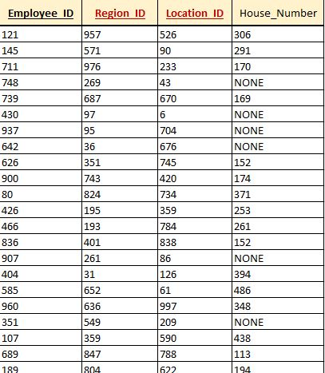

Table is normalized, it’s in 3NF allready.

PK is employee_ID.

FK are location_ID and region_ID.